H.T No
Regulations:
A19

Sreenidhi Institute of Science and Technology
(An Autonomous Institution)
Code No: 7P261 Date: 21-April-2022 (FN)

M.Tech I-Year II-Semester External Examination, April/May - 2022 (Supplementary)
ARTIFICIAL INTELLIGENCE & DEEP LEARNING (CSE and CS)

Time: 3 Hours Max.Marks:70

Note: a) No additional answer sheets will be provided.
b) All sub-parts of a question must be answered at one place only, otherwise it will not be valued.
c) Missing data can be assumed suitably.

ANSWER ANY 5 OUT OF 8 QUESTIONS. EACH QUESTION CARRIES 14 MARKS.

Bloom's Cognitive Levels of Learning (BCLL)

Remember | L1 | Apply | L3 | Evaluate | L5
Understand | L2 | Analyze | L4 | Create | L6

 |  |  | BCLL | CO(s) | Marks
1. | a) | What is Artificial Intelligence? What are the various applications of Artificial Intelligence? | L1 | CO1 | [7M]
 | b) | Discuss problem solving agents. | L1 | CO1 | [7M]
2. | a) | Write and explain A* Algorithm with an example. “A* is admissible” justify the statement. | L2 | CO2 | [7M]
 | b) | Explain Alpha-Beta pruning with suitable example. | L1 | CO2 | [7M]
3. | a) | Prove that “Jill killed the cat” using resolution refutation.  i) Everyone who loves all animals is loved by someone.  ii) Anyone who kills an animal is loved by no one.  iii) Tack loves all animals  iv) Either Jack or Jill killed the cat whose name is Tina | L5 | CO3 | [7M]
 | b) | Discuss issues in Knowledge representation. | L1 | CO3 | [7M]
4. | a) | In the following cyclic MDP calculate Q(p,A) where C(a)=4 , C(b)=9 C(c)=1  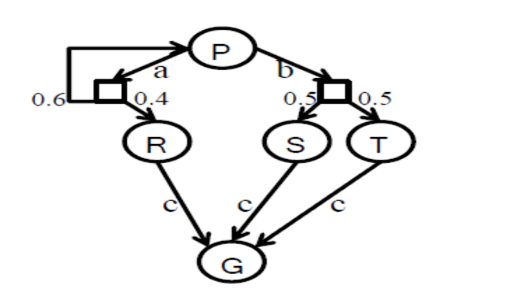 | L5 | CO4 | [7M]
 | b) | Describe the role of probability theory in AI | L1 | CO4 | [7M]
5. | a) | Explain the process of convolution neural network for recognition of images, demonstrate with MNIST dataset. | L1 | CO5 | [7M]
 | b) | Discuss image feature selection techniques. | L2 | CO5 | [7M]
6. | a) | What is Markov Decision Process? Explain with an example. | L1 | CO6 | [7M]
 | b) | Write about Q Learning. | L2 | CO6 | [7M]
7. | a) | What is generic knowledge- based agent?. | L1 | CO1 | [5M]
 | b) | Which is the best approach to go for Game playing problem? Explain it. | L3 | CO2 | [5M]
 | c) | What is unification? | L1 | CO3 | [4M]
8. | a) | Explain utility function. | L1 | CO4 | [5M]
 | b) | List the objectives of MDP. | L1 | CO5 | [5M]
 | c) | Write about pole cart. | L1 | CO6 | [4M]

-- 00 -- 00 –

